

Adding Realities to State of Our City Tool

(Retrieving, Analyzing and Modeling Data)

DSBA-6400 Internship - Spring 2024

Reta Giblin

Robert Fox – Faculty Advisor

Andrew Weiler – Mentor

Table of Contents

Executive Summary 3

Introduction and Background 4

Methods 5

Results 6

Marriage Reality 6

Disability Reality 8

Upward Mobility Reality 11

Discussion 13

Conclusions 14

Appendix 15

Role of Mentor 15

Integration with Coursework 15

# Executive Summary

For Charlotte is a non-profit organization that helps connect churches to areas of need in Charlotte. The organization creates content, gathers resources, and facilitates a learning environment to equip pastors and church leaders to most effectively meet the needs of those with inadequate resources in the Charlotte metro region. One of the resources For Charlotte provides is the State of Our City resource which used to be a printed report but last year became an online tool (<https://charlotte.stateofourcity.com/en>). It is a tool that helps churches find the most pressing needs in the city. The tool currently covers 9 “Realities”, or areas of need: Affordable Housing, Childhood Literacy, Church Growth/Decline, Educational Attainment, Family Flourishing, Foster Care, Immigrants & Refugees, Life Expectancy & Religious Affiliation.

For Charlotte wants to add three new Realities to the State of Our City Tool. The goal of this internship was 1) to assist For Charlotte in determining what 3 new Realities to add and 2) determine the bellwether statistic for each Reality as well as the four supporting statistics. This involved researching each potential areas to add, as well as finding, cleaning, and analyzing data about each area of need. Possible new Realities or areas of need originally included Marriage, Disability, Upward Mobility & Millennials/Gen Z. Of the original potential additions, it was determined that the Millennials/Gen Z Reality would be the best Reality to omit, as the data needed to take the Reality live would be cost prohibitive.

As mentioned above, the State of Our City tool highlights five different areas or statistics about each Reality: a Bellwether statistic and four supporting statistics. A significant amount of time was spent locating and acquiring data. Most, but not all the data used was acquired from the U.S. Census Bureau’s American Community Studies. Once the data was obtained, it was analyzed, manipulated, and summarized to provide the necessary statistics. K-means clustering was also used to assist in obtaining some metrics.

While this internship involved doing all the research and creating the key metrics for each Reality, the development team for the State of Our City Tool will implement the new Realities into the tool’s web interface. The statistics and methods used in this internship will lay the groundwork to retrieve all the statistics necessary, at each level necessary, to populate the tool. Once live, the new Realities will allow users to determine where resources are needed to help with marriages, the disabled, and the poor in Charlotte.

# Introduction and Background

The business objectives for this internship are adding three new realities to the State of Our City online tool. These new realities will allow churches to do research and figure out where the need is around marriage, disabilities, and upward mobility in the Charlotte metro region. This will help the churches choose where to donate resources and time.

Adding these Realities involved determining what the bellwether statistic was going to be for each new Reality, as well as what the four ‘By the Numbers’ supporting statistics were going to be.

The first business objective was to add a Marriage Reality. The Adjusted Divorce Rate was the most important aspect about Marriage, so it became the bellwether statistic. Other important information that would be highlighted in the ‘By the Numbers’ sections are:

1. Age of first marriage
2. Comparison of never married and never married but cohabitating
3. Number getting married by generation
4. Number getting married by education level

The second business objective was to add a Disability Reality. The Bellwether for the Disability Reality is the number and/or percent of people with a disability. Other important information that would be highlighted in the ‘By the Numbers’ are:

1. Types of disabilities present
2. Age of people with a disability
3. Ways people with disabilities commute to work
4. How many people with disabilities are suffering from poverty

The third business objective was to add an Upward Mobility Reality. Due to the vast amount of information available about Upward Mobility, we used modeling to determine which factors contributed most to Upward Mobility. The bellwether Statistic is the percentage of an area that qualifies as not upwardly mobile. Other important information that would be highlighted in the ‘By the Numbers’ are:

1. Household income.
2. Employment Rate
3. Teen Birthrate
4. Educational attainment.

# Methods

Before adding a new Reality, we had to educate ourselves about the area the Reality would cover. This involved reading books, figuring out who the experts were in each area, and assessing their work and reviewing studies.

Earlier the Millenials/Gen Z Reality was mentioned. Significant research was performed on this Reality, including reading the book Zconomy, How Gen Z Will Change The Future of Business and What To Do About It by Jason Dorsey and Denise Villa. Learning about Gen Z and Millennials would be a valuable resource for churches, especially since so many of from these generations are foregoing churchgoing. However, a cost-effective source of data could not be found as most data about these Gen Z and Millennials is paywalled. Therefore, this Reality was postponed until a source of funding to cover the cost of the data could be secured or until free data could be located.

One method we used to learn about marriage and upward mobility was readying the book The Two-Parent Privilege, How Americans Stopped Getting Married and Started Falling Behind by Melissa S. Kearney. Other resources included podcasts and studies.

The data for the first two Realities, Marriage and Disabilities, was obtained from the U.S. Census Bureau’s 2022 American Community Survey. The data was accessed via an API from the R programming language. The data for the first two Realities was retrieved using two different methods. The numbers needed for the Marriage Reality were not precalculated and readily available from the census, so individual census records were retrieved using the tidycensus package in R and R was used to do the data manipulations and calculations. The numbers for the Disability were readily available and just had to retrieved through the API.

The Upward Mobility data was retrieved from a combination of data sources. The original data was retrieved from the Opportunity Insights Opportunity Atlas. (<https://www.opportunityatlas.org/>) The latest data available from this source was 2016. The data from the Opportunity Atlas proved valuable for a K-means model to show what factors lead the upward mobility. Then more updated data was obtained from the U.S. Census Bureau and from National Center for Health Statistics at the CDC. This new data was also run through a K-means clustering and mirrored the previous clustering to show which factors lead to upward mobility and which areas allowed for upward mobility.

Please see the figure below for a diagram of the process for each of the three Realities:

Identify Data Source

Identify Bellwether

Identify 3 –By the Numbers

Reading & Research

Extract Data

Model Data

Analyze & Summarize

# Results

## Marriage Reality

The first objective was achieved, and the Marriage Reality data was obtained. We did have to revisit the Marriage Reality a couple of times to make modifications. Most notably, the divorce rate had to be recalculated to the adjusted divorce rate. Please see a sampling of the statistics calculated for the Marriage Reality below.

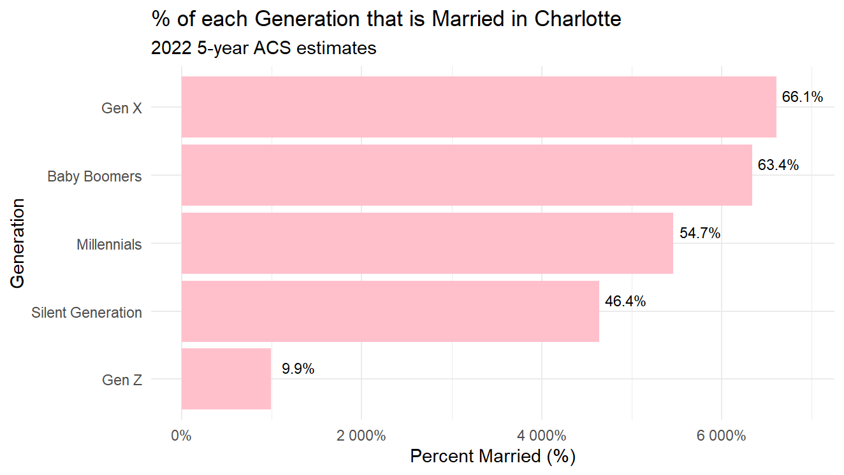

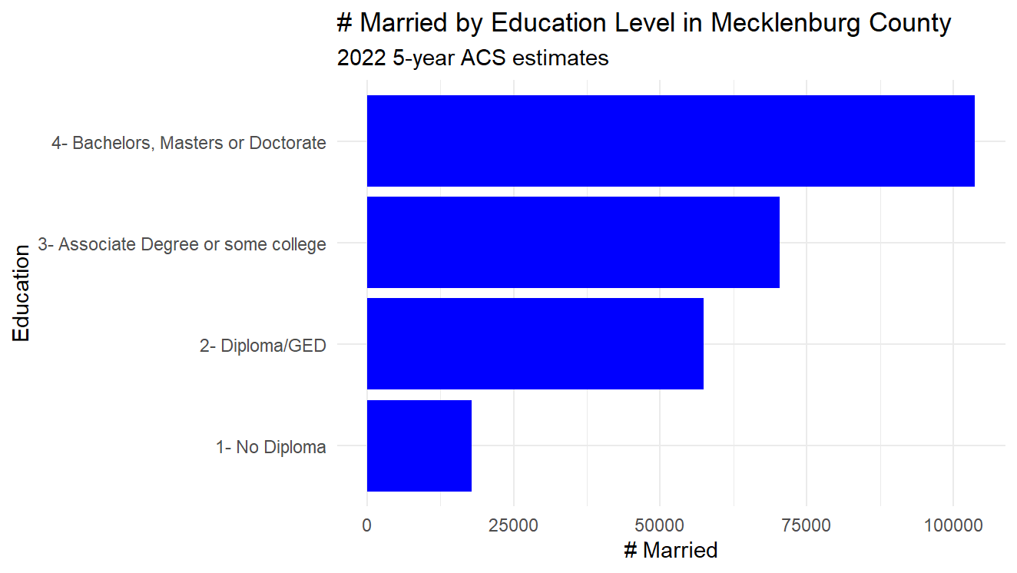

## Disability Reality

The second objective was achieved, and the Disability was retrieved and analyzed. This Reality was the most straightforward and did not require manipulations. Here is a sampling of data acquired about people with disabilities in Charlotte.

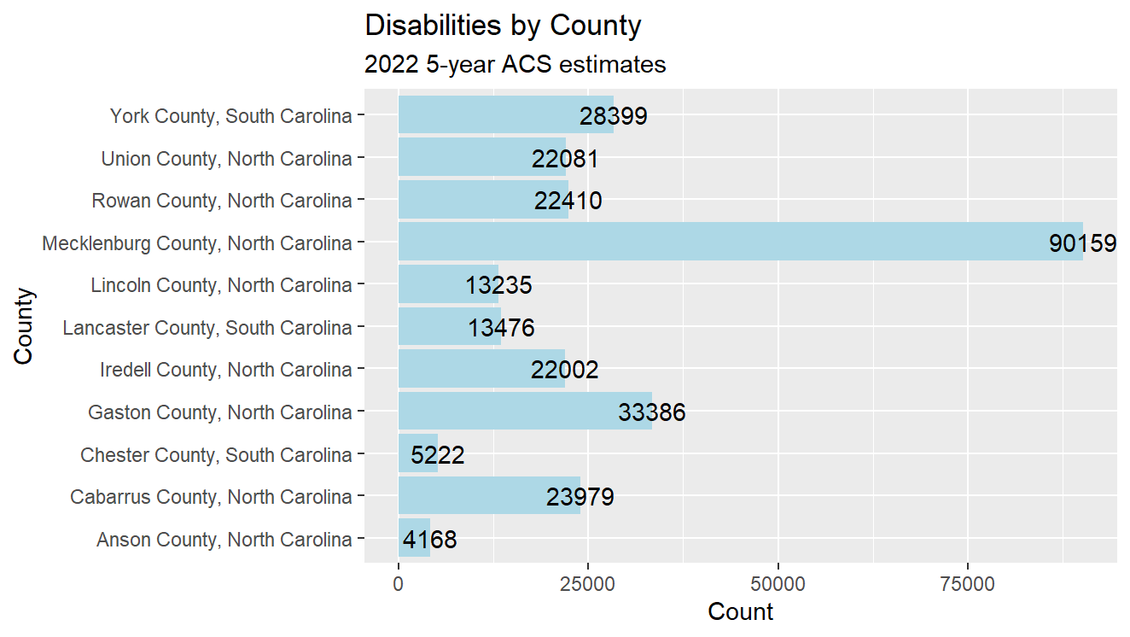

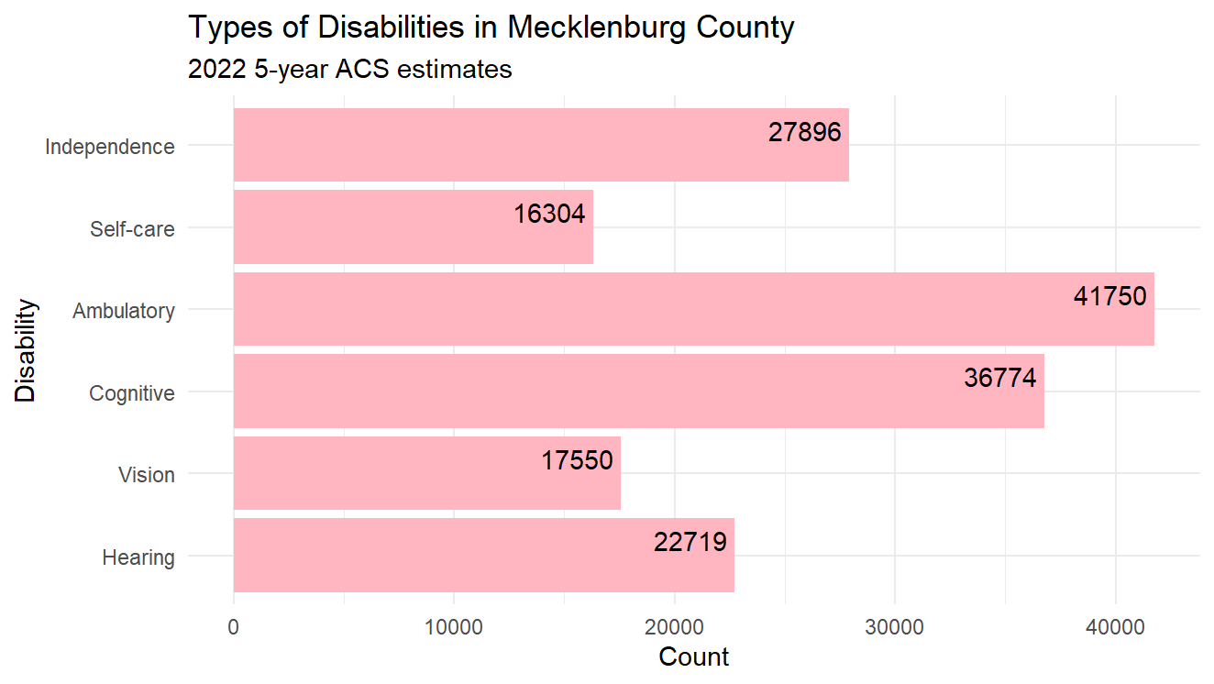

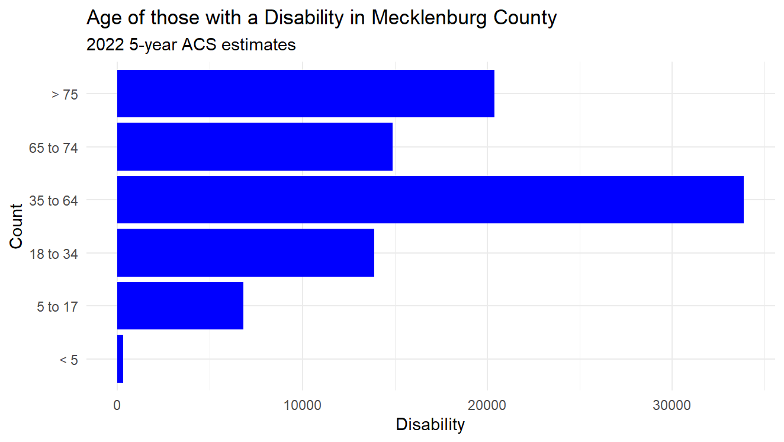

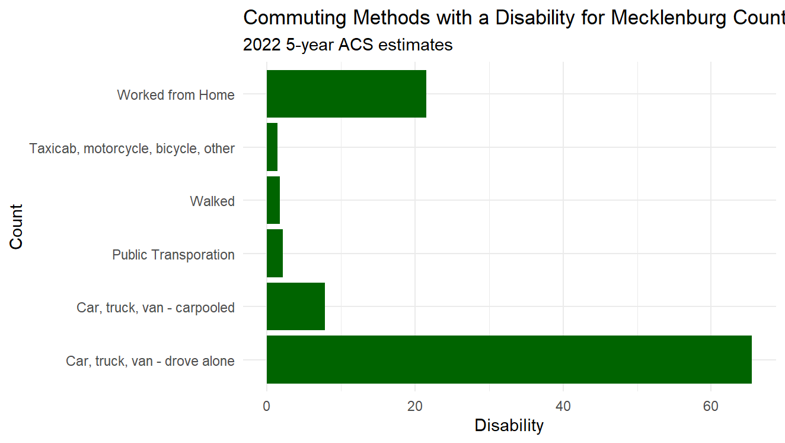

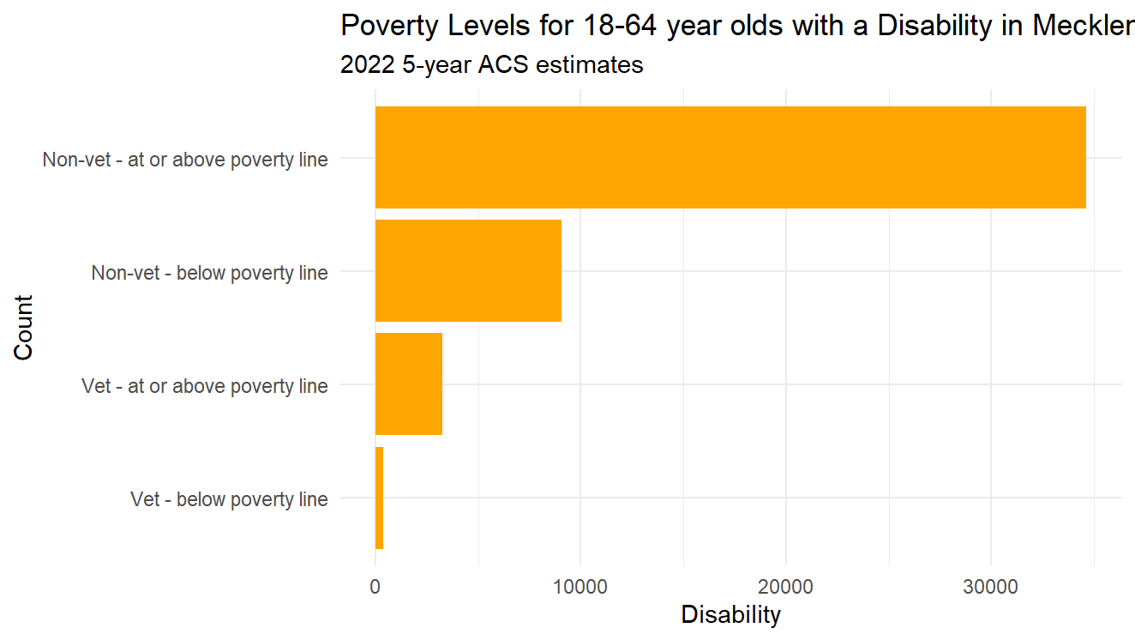

## Upward Mobility Reality

The third objective was to add the Upward Mobility Reality. There are many factors that contribute to upward mobility. One of the methods used to gain insights into the data was K-means clustering. Several factors that likely contributed to upward mobility were clustered. Both the elbow and silhouette method indicated that 2 clusters would be optimal.

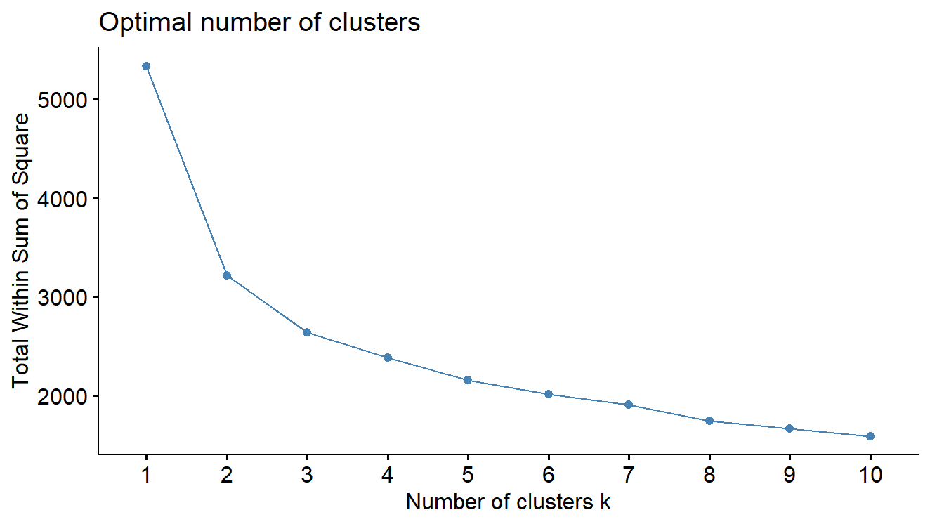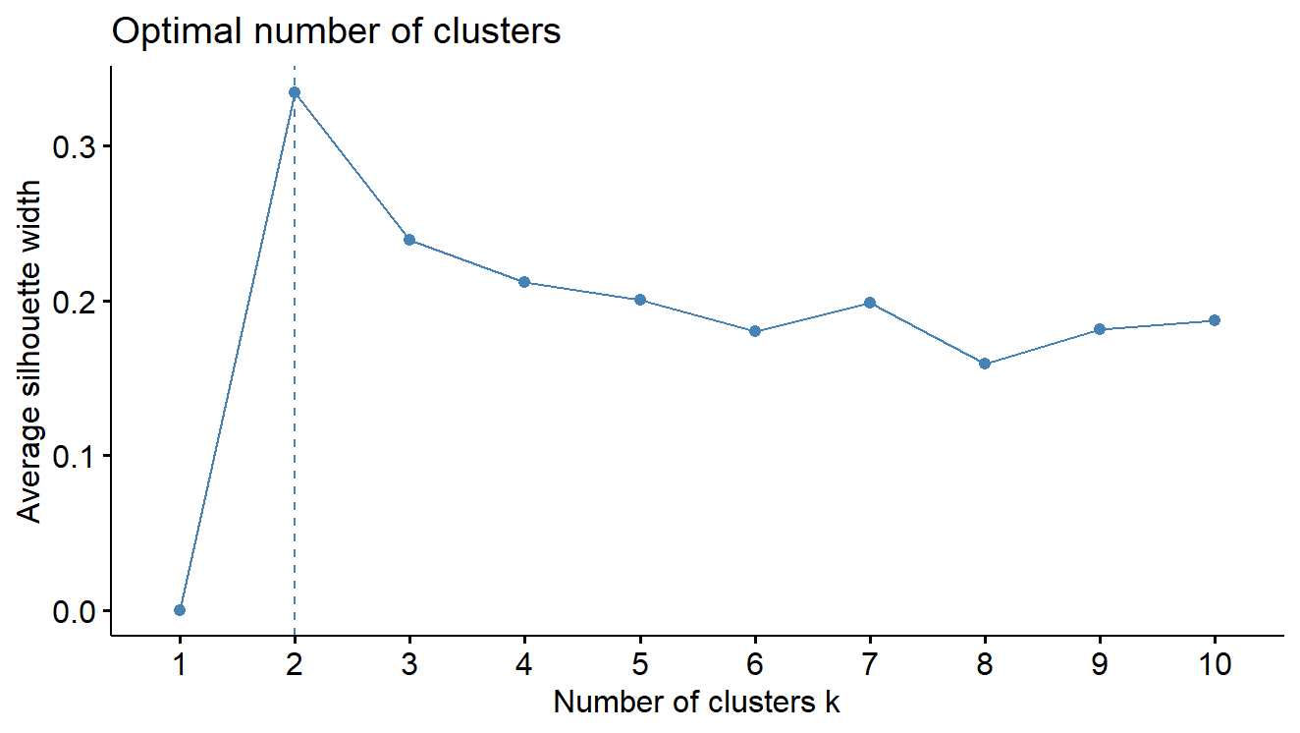

The clusters plot as follows:

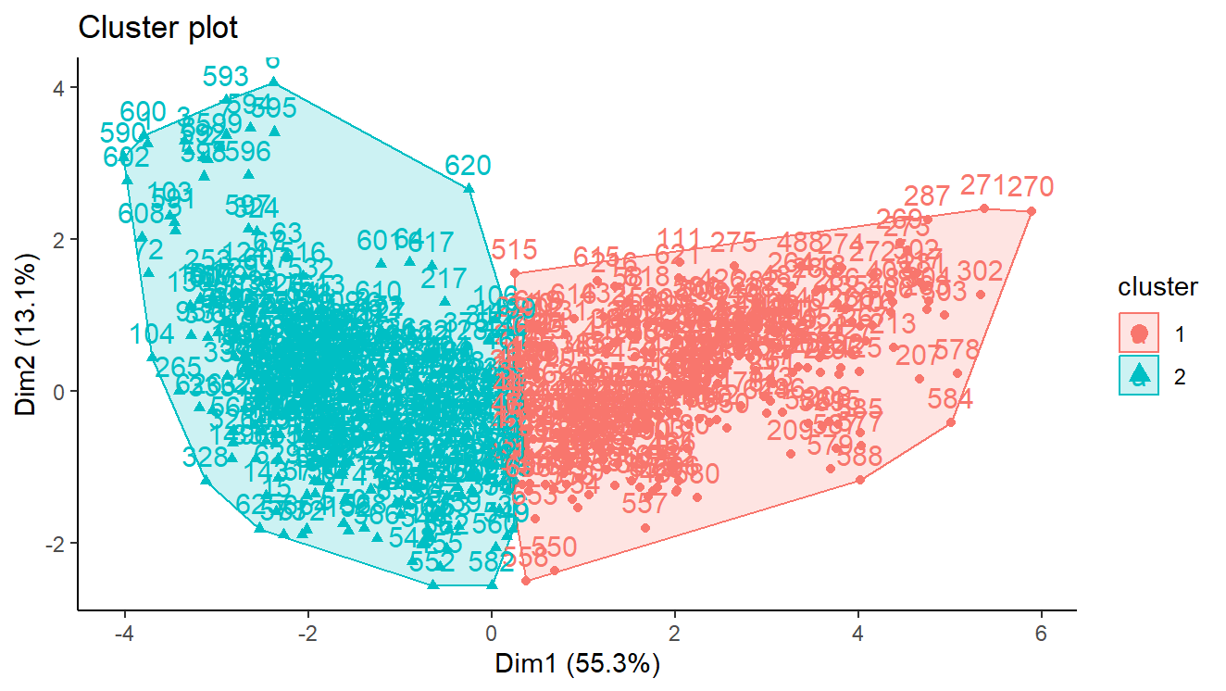

The following table summarizes what the clusters indicate:

|  |  |
| --- | --- |
| Cluster 1 | Cluster 2 |
| Higher income | Lower income |
| Higher employment rate | Lower employment rate |
| Lower teen birthrate | Higher teen birth rate |
| Less with less than a high school education | More with less than a high school education |
| Less with a high school diploma or GED only | More with a high school diploma or GED only |
| Less with only some college | More with only some college |
| Many with a bachelor’s degree | Less with a bachelor’s degree |
| More with a master’s or professional degree | Less with a master’s or professional degree |

Based on the summary in the above table, cluster one contains areas where there has been greater upward mobility and cluster 2 contains areas where there has been less upward mobility. The cluster sizes show that there are 290 census tracts that fall into the cluster with more likelihood of upward mobility, while there are 378 census tracts that fall into the cluster with less upward mobility. This data will provide the Bellwether statistic, though it hasn’t been finalized at this time exactly how it will be displayed. The map below shows were the clusters map to census tracts in the Charlotte metro region.

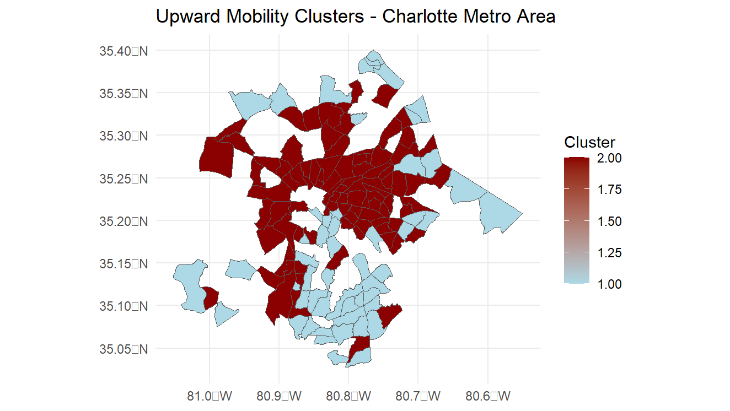

The other factors that determine upward mobility and that will be highlighted in the By the Numbers sections are household income, employment rate, marriage rate, teen birth rate and educational attainment. While this data has been retrieved, it will be decided at a later time how the data will be displayed.

# Discussion

There were many interesting things discovered during the process of research, many of them around the Marriage and Upward Mobility Realities. Both the marriage and the divorce rates have been declining for decades. (See graph below.)

**

The age at first marriage chart in the Marriage section above highlights the fact that the age that people are getting married is rising. The average age of marriage in Charlotte was 29 for 2022. In fact, many in the younger generations are foregoing to institution of marriage altogether and choosing to cohabitate instead, as is also highlighted by the graph in the Marriage section.

When looking at marriage by education level, one can see that the less educated a person is, the less likely they are to be married. In contrast, the college educated individuals are continuing to marry at about the same rate.

# Conclusions

Once the Realities discussed above have gone live in the State of Our City tool, it will give pastors and other church leaders, as well as other groups looking to help the underprivileged in Charlotte, a resource for determining where the greatest needs in Charlotte metro region are around marriage, disabilities and upward mobility.

# Appendix

## Role of Mentor

My mentor, Andrew Weiler and I met for about an hour almost every Tuesday and Thursday since late December. Since Andrew has been with For Charlotte for a long time and was integral in implementing the first 9 Realities, he was an invaluable resource. He guided the direction of the research and suggested resources to dive into topics in more detail. Additionally, he was a great sounding board for running data and conclusions by. We also collaborated with Rob Kelly and other For Charlotte team members and partners to make sure the end-product would meet the organization’s goals.

## Integration with Coursework

This internship integrated many of the skills learned and practiced in the courses in the DSBA master’s program. In class we talked about acquiring, preparing, and cleaning data for analysis, but much of the data we were given to model was very clean. This project reinforced that getting the data and getting it ready for modeling is a huge part of the effort in any data modeling project.

This project also required obtaining the data through an API to the U.S. Census Bureau. This was an educational exercise as I had to figure out how to use the tidycensus package in R to obtain the data.

Once the data was obtained, Exploratory Data Analysis (EDA) needed to be performed. This is a topic we covered in many courses as well. A lot of the work for this project was finding and filtering the data, but some data modeling was involved. For example, there are many factors that contribute to upward mobility. Once we researched and figured out what some of the more salient variables were, we were able to use those and create clusters using k-means clustering that helped us understand how the variables worked together and against each other to contribute to upward mobility.